Name: Bharath Arun Gandhimani Student ID: 35501308
Teaching Associate: Michael Niemann & Ayden Zhou Applied Session 7

FROM ROADS TO CLASSROOMS: EDUCATIONAL INFRASTRUCTURE INVESTMENT, SOCIOECONOMIC EQUITY, AND HOUSEHOLD TRAVEL BEHAVIOUR IN VICTORIA (2023–2025)

Table of Contents
1. Introduction 2
2. Data Wrangling and Checking 2
Data Sources 2
Data Checking and Error Correction 2
Derived Variables and Transformations 3
Documented Limitations 3
3. Data Exploration 3
Research Question 1: How do daily travel patterns for work and education differ across regions with different levels of government infrastructure investment? 3
Research Question 2: How does the economic status of a neighbourhood shape the way its residents travel day to day? 5
Research Question 3: How is government infrastructure investment distributed across Victorian areas relative to where households are located? 9
4. Conclusion 10
5. Reflection 11
Bibliography 12
Generative AI Declaration 12
Appendix 12

1. Introduction
Victoria's 2023–24 State Budget directed substantial public funding toward educational infrastructure across the state, with new school constructions, upgrades, and early learning centres forming the largest category of spatially mapped investment projects (Victorian Department of Treasury and Finance, 2023). At the same time, the Victorian Integrated Survey of Travel and Activity (VISTA) 2024–25 captures the daily movement of households across Greater Melbourne and Geelong — recording where people go, how they get there, and how long it takes. What remains poorly understood is whether these two realities — where the government is building and where people actually live and travel — are meaningfully aligned, and whether a household's economic circumstances shape its transport options independently of any infrastructure investment.
This project brings together three open datasets — VISTA 2024–25, the State Budget Infrastructure Investment Map, and the ABS Socio-Economic Indexes for Areas (SEIFA) 2021 — to explore these questions across Victorian Local Government Areas (LGAs). The analysis is guided by three research questions. First, how do daily travel patterns for work and education differ across regions with different levels of government infrastructure investment? Second, how does the economic status of a neighbourhood shape the way its residents travel day to day? Third, how is government education infrastructure investment distributed across Victorian areas relative to where households are located?
The findings are relevant to transport planners, education authorities, and policymakers seeking to understand whether infrastructure spending reflects the lived mobility demands of Victorian communities, and whether socioeconomic factors systematically limit the transport options available to disadvantaged households.

2. Data Wrangling and Checking

Data Sources
Three datasets were used in this project. The VISTA 2024–25 survey (Department of Transport and Planning, Victoria, 2025) is a relational dataset comprising three linked files: trips (19,864 rows × 65 columns), persons (6,404 rows × 53 columns), and households (2,486 rows × 28 columns). It records daily travel behaviour including trip purpose, transport mode, origin and destination LGA, trip duration, and distance, alongside demographic and household attributes. The State Budget Infrastructure Investment Map 2023–24 (Victorian Department of Treasury and Finance, 2023) is a spatial dataset containing 356 infrastructure projects with geographic coordinates, investment values, and project type descriptions; after filtering to education-themed entries only, 181 projects remained. The ABS SEIFA 2021 LGA Indexes (Australian Bureau of Statistics, 2023) is a tabular dataset providing socioeconomic decile rankings for all Australian LGAs across four indexes, of which the Index of Relative Socio-Economic Disadvantage (IRSD) and Index of Education and Occupation (IEO) were used in this project.
All data wrangling was performed in Python using the pandas library. The VISTA trip file was merged with the person file on the shared identifier persid, and the resulting dataset was subsequently merged with the household file on hhid. This produced a single analytical file of 19,864 trip-level rows retaining all demographic, household, and trip attributes. Investment project data was processed separately to generate LGA-level project counts and investment tier classifications, which were then joined to the merged VISTA dataset on a standardised LGA name key. SEIFA decile scores were joined using the same standardised key. The final merged dataset (vista_merged_final.csv) contains 114 columns spanning all variables from the five source files.

Data Checking and Error Correction
A comprehensive checking process was conducted across all datasets. Eight errors were identified and corrected, documented below.
The hhinc_group field in the household file contained 73 missing values representing genuine survey refusals rather than data entry errors. These were filled with the string "Not Stated" to distinguish them analytically from structural missingness. The totalbikes field contained 244 entries coded as the string "Missing/Refused" rather than a numeric value; these were converted to NaN to enable numeric aggregation. The numstops field contained 60 similarly coded refusal strings, which were likewise converted to NaN. Both errors were identified by inspecting the full value distribution of each field, which revealed non-numeric categories alongside valid counts, as shown in Figure A1 in the Appendix. The cumdist field contained 104 trip rows coded as the string "Missing" rather than a numeric distance; these were converted to NaN, and cumdist was subsequently excluded as a primary variable in all analyses given the extent of missingness.
The starthour field contained 80 trip records with values between 24 and 27, representing overnight trips that crossed midnight. This was identified by plotting the full distribution of starthour values, which revealed a visible spike beyond the valid 0–23 range, as shown in Figure A2 in the Appendix. These values were recoded to 0 through 3 respectively in a new derived column starthour_norm to maintain temporal ordering without distorting the 0–23 hour scale. In the State Budget dataset, the investment column name contained a trailing whitespace character that caused join failures; this was corrected by stripping the column name before processing. Three LGA name mismatches were identified between the VISTA and SEIFA datasets: Bayside appeared as Bayside (Vic.) in SEIFA, Kingston as Kingston (Vic.), and Merri-bek as Moreland. A mapping dictionary was applied to standardise names prior to the SEIFA join. Finally, five trip records in the VISTA trips file had travel times exceeding 480 minutes, which is implausible for a single-day urban trip, as shown in Figure A3 in the Appendix. These were flagged with a boolean column triptime_flag and excluded from visualisations involving trip duration, but retained in the dataset to preserve full record counts.

Derived Variables and Transformations
Several derived variables were created to support analysis. Transport modes recorded across nine individual mode columns were consolidated into a mode_group variable with five categories: Private Vehicle, Public Transport, Active Transport, Ride-hailing, and Other. Investment tier classifications were assigned to each LGA based on project count: None (0 projects), Low (1–2), Medium (3–5), and High (6+). SEIFA IRSD deciles were joined at LGA level and appended to all trip and household records. A pre-filtered dataset (we_trips_final.csv) was created containing only Work Related and Education trips for focused Q1 analysis.

Documented Limitations
Five primary limitations were identified and documented below; two additional limitations are noted inline within the error corrections above.
VISTA covers Greater Melbourne and Geelong only, meaning 29 Victorian LGAs with budget investment have no matching travel survey data; Q3 spatial analysis is therefore restricted to 33 overlapping LGAs. SEIFA deciles are from the 2021 Census while VISTA data spans 2024–25, introducing a three-year temporal gap; 2021 is the most recent SEIFA release available. The IRSD decile range within VISTA coverage areas is 2–10 only, as no surveyed households reside in the nationally most disadvantaged decile. Investment dollar values were not used because 261 of 330 located budget entries share bundled dollar amounts across multiple LGAs; project count was used instead to avoid double-counting. Spatial analysis is conducted at LGA centroid level as VISTA contains no precise household coordinates.

3. Data Exploration
The exploration was conducted in R using ggplot2, with statistical testing performed using the rstatix package. Visualisations were designed to directly address each research question through complementary chart types, and statistical tests were applied where visual patterns required formal verification.

Research Question 1: How do daily travel patterns for work and education differ across regions with different levels of government infrastructure investment?
Analysis for Q1 was restricted to weekday trips only, using the we_trips_final.csv dataset pre-filtered to Work Related (2,811 weekday trips) and Education (1,057 weekday trips) purposes. Weekend trips were excluded because weekend travel patterns differ materially from weekday commuting and schooling behaviour — private vehicle use rises substantially and trip purposes shift away from regular work and education, which would distort comparisons intended to reflect typical daily mobility.
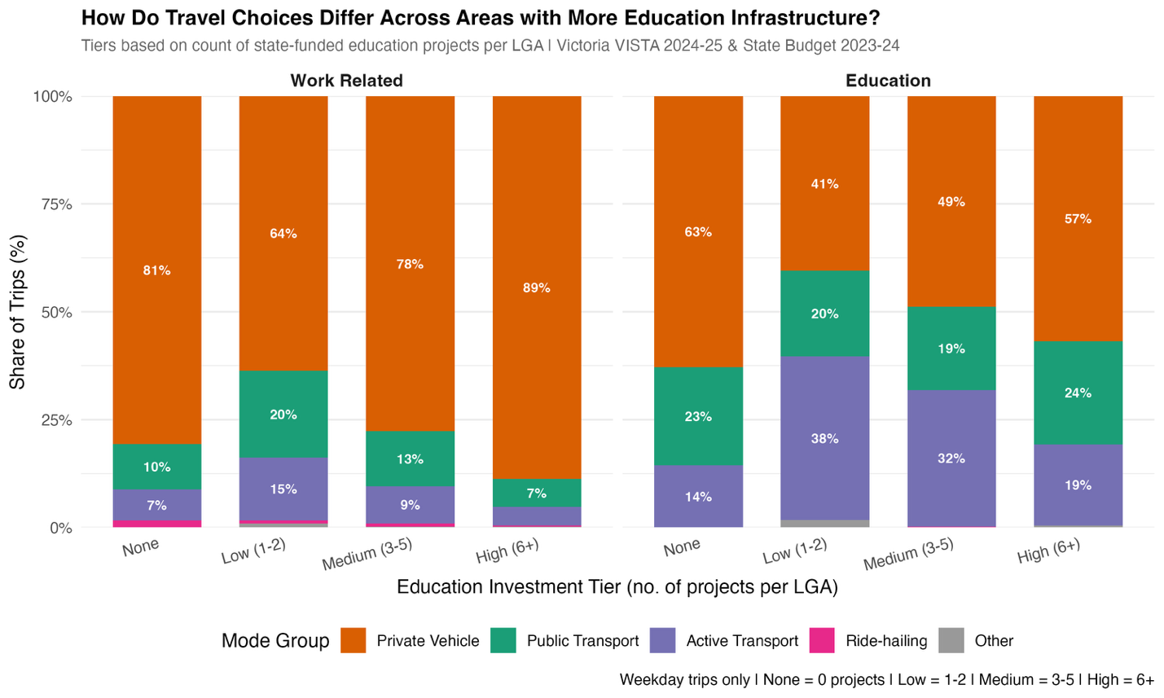
Figure 1. Stacked bar chart showing the proportional share of each transport mode group for weekday work and education trips, disaggregated by LGA education investment tier. Source: VISTA 2024–25; State Budget 2023–24.
Figure 1 presents mode share across four investment tiers, faceted by trip purpose. A stacked bar chart was selected because it effectively encodes part-to-whole relationships across an ordered categorical variable, allowing direct visual comparison of proportional composition rather than raw counts. The investment tier ordering (None → Low → Medium → High) was treated as an ordinal axis to preserve the implied gradient of infrastructure investment.
For work-related trips, private vehicle dominance increases substantially with investment tier — from 81% in areas with no investment to 89% in High-tier areas. Public transport and active transport shares decline correspondingly. This pattern likely reflects the geographic character of High-investment LGAs rather than a causal effect of investment: areas such as Casey, Hume, and Melton are outer suburban growth corridors where distances are too large for active transport and public transport coverage is limited. For education trips, the pattern is reversed and more complex. Low-investment areas have the highest active transport share (38%) and the lowest private vehicle share (41%), while High-investment areas show the highest private vehicle use for education (57%) and the lowest active transport share (19%). This counterintuitive finding suggests that LGAs receiving more education investment tend to be outer suburban areas where children cannot easily walk or cycle to school, and school drop-off by car is the dominant pattern.
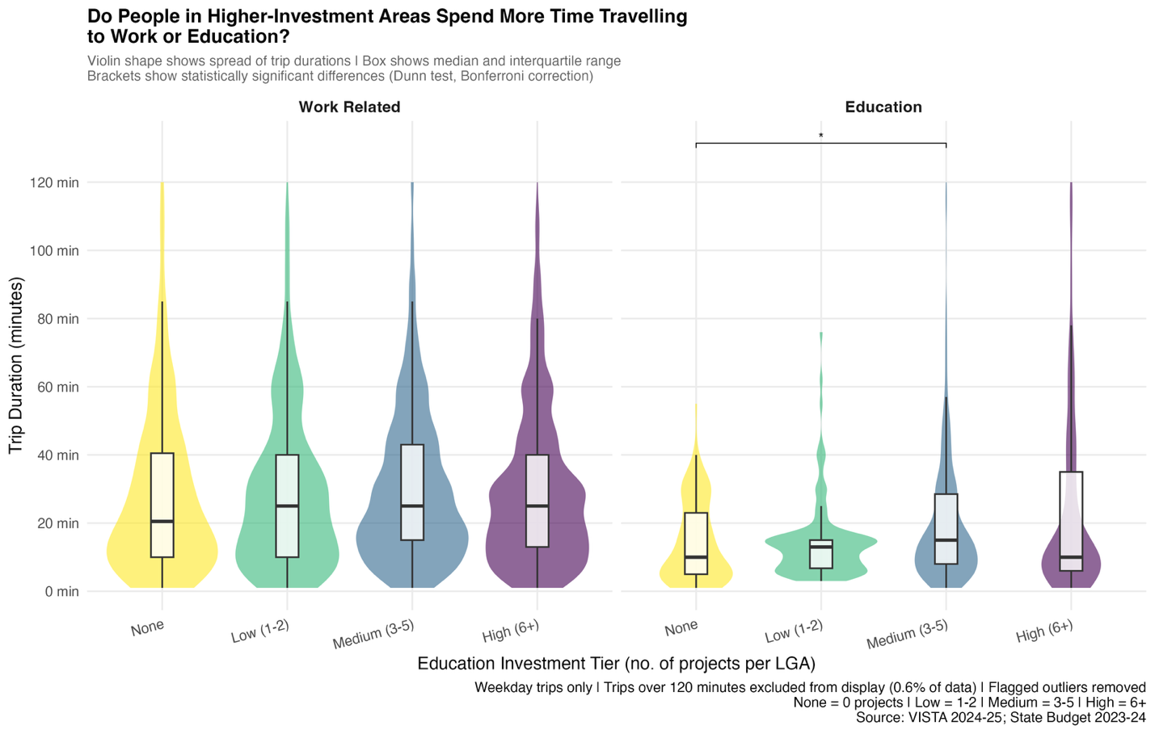
Figure 2. Violin plots showing the distribution of weekday trip durations across investment tiers, faceted by trip purpose. Brackets indicate statistically significant pairwise differences (Dunn test, Bonferroni correction). Source: VISTA 2024–25; State Budget 2023–24.
Figure 2 examines whether trip duration varies across investment tiers. A combined violin and boxplot idiom was chosen because it simultaneously conveys distribution shape — which is right-skewed for trip durations — alongside the median and interquartile range. Trips flagged as implausible outliers (over 480 minutes) were excluded, and display was capped at 120 minutes, which excluded an additional 0.6% of trips.
A Kruskal-Wallis test was applied to each trip purpose group separately, with Dunn post-hoc tests using Bonferroni correction for pairwise comparisons. For work-related trips, no statistically significant differences were found across any investment tier pair, indicating that trip duration for work commutes is consistent regardless of the level of education investment in the home LGA. For education trips, a significant difference was identified between None-tier and Medium-tier areas (p = 0.022), with Medium-tier LGAs showing a higher median education trip duration (15 minutes compared to 10 minutes for None-tier). This is likely attributable to the geographic extent of Medium-tier LGAs such as Cardinia and Mornington Peninsula, where schools may not be within walking distance of all households.

Research Question 2: How does the economic status of a neighbourhood shape the way its residents travel day to day?
Q2 used two datasets: vista_merged_final.csv for trip-level analysis and hh_seifa_final.csv for household-level vehicle ownership analysis. Neighbourhood economic status was operationalised using the IRSD decile, where higher deciles indicate less disadvantaged neighbourhoods.
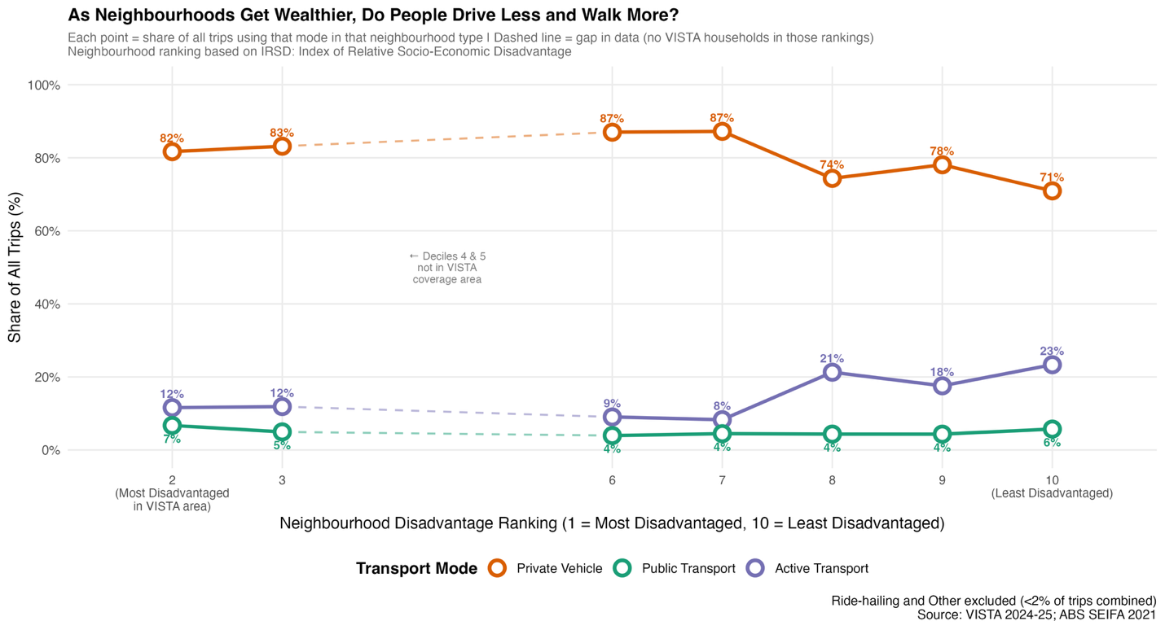
Figure 3. Connected dot plot showing the share of trips made by each major transport mode across neighbourhood disadvantage rankings. Dashed line indicates a gap in data where no VISTA households reside in those rankings. Source: VISTA 2024–25; ABS SEIFA 2021.
Figure 3 was chosen over a heatmap because the connected dot plot makes trend direction immediately readable across an ordered quantitative axis, whereas a heatmap's colour scale could not adequately differentiate small percentage changes across modes with very different absolute magnitudes. Ride-hailing and Other categories were excluded as they collectively represent under 2% of all trips.
The most striking pattern is the sharp rise in active transport share from 8% at Ranking 7 to 23% at Ranking 10 — nearly tripling across three decile steps. Private vehicle use follows the inverse trajectory, dropping from a peak of 87% at Rankings 6–7 to 71% at Ranking 10. Public transport remains flat at 4–7% across all rankings, suggesting that public transport access does not meaningfully vary with neighbourhood wealth within the VISTA coverage area. The active transport increase at higher rankings reflects the geographic reality that the least disadvantaged VISTA LGAs (Rankings 8–10) are predominantly inner Melbourne suburbs such as Yarra, Port Phillip, and Boroondara, where walkable urban environments make active transport a viable daily option. This is a geography effect as much as an economic one, and is noted as a limitation of LGA-level analysis.
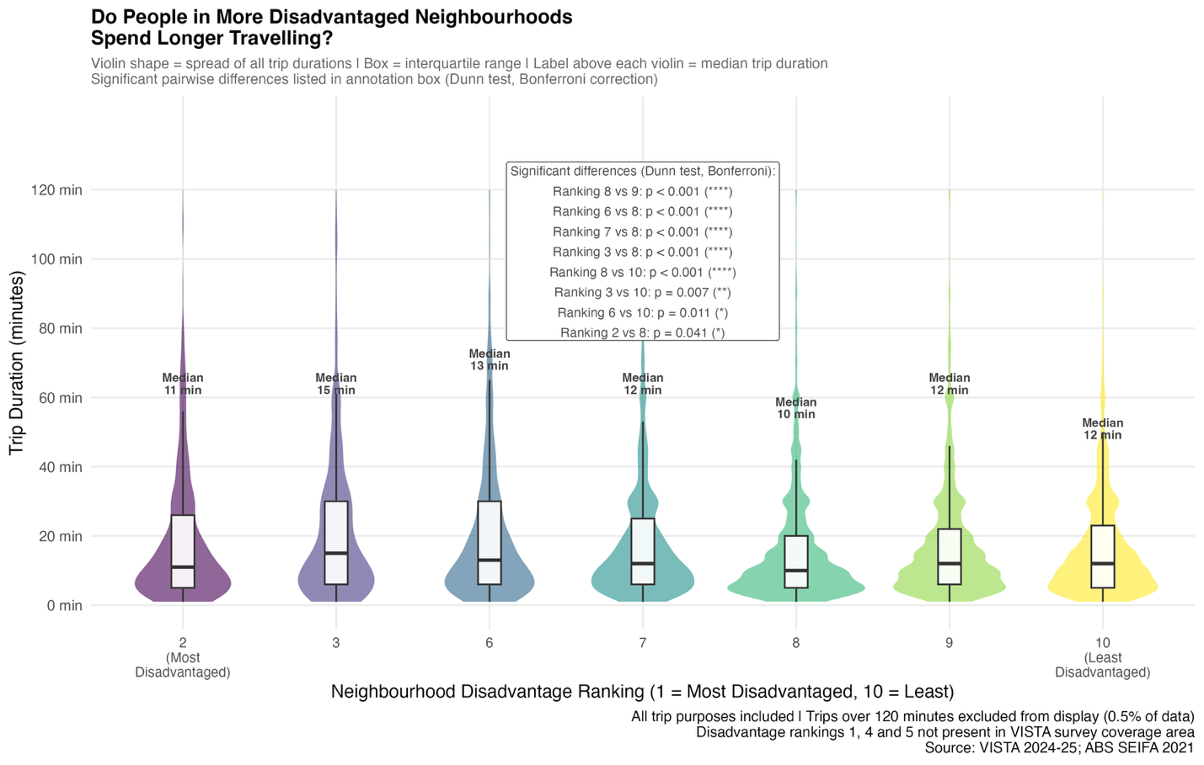
Figure 4. Violin plots showing the distribution of all trip durations across neighbourhood disadvantage rankings. Significant pairwise differences are listed in the annotation box (Dunn test, Bonferroni correction). Source: VISTA 2024–25; ABS SEIFA 2021.
Figure 4 applies the same violin idiom used in Figure 2 for consistency, and includes all trip purposes since Q2 concerns general daily mobility rather than work or education trips specifically. The Kruskal-Wallis test confirmed that trip duration distributions differ significantly across rankings. Dunn post-hoc tests identified eight significant pairwise differences. Ranking 8 — corresponding to inner-to-middle Melbourne suburbs — has a median trip duration of 10 minutes and is significantly shorter than Rankings 2, 3, 6, 7, 9, and 10 (all p < 0.05). Ranking 3 is significantly longer than both Ranking 8 (p < 0.001) and Ranking 10 (p = 0.007), and Ranking 6 is significantly longer than both Ranking 8 (p < 0.001) and Ranking 10 (p = 0.011).
The answer to Q2 in terms of trip duration is not a simple linear relationship. Ranking 8 is a clear minimum — significantly below nearly every other ranking — while Ranking 3, a moderately disadvantaged category, has the longest median at 15 minutes. This non-linear pattern suggests that trip length is shaped more by urban density and land-use mix than by socioeconomic disadvantage alone. Ranking 8 corresponds to inner-to-middle Melbourne suburbs where destinations are in close proximity, while Rankings 2–3 and Rankings 6–7 represent more dispersed outer or regional areas where trips necessarily cover greater distances.
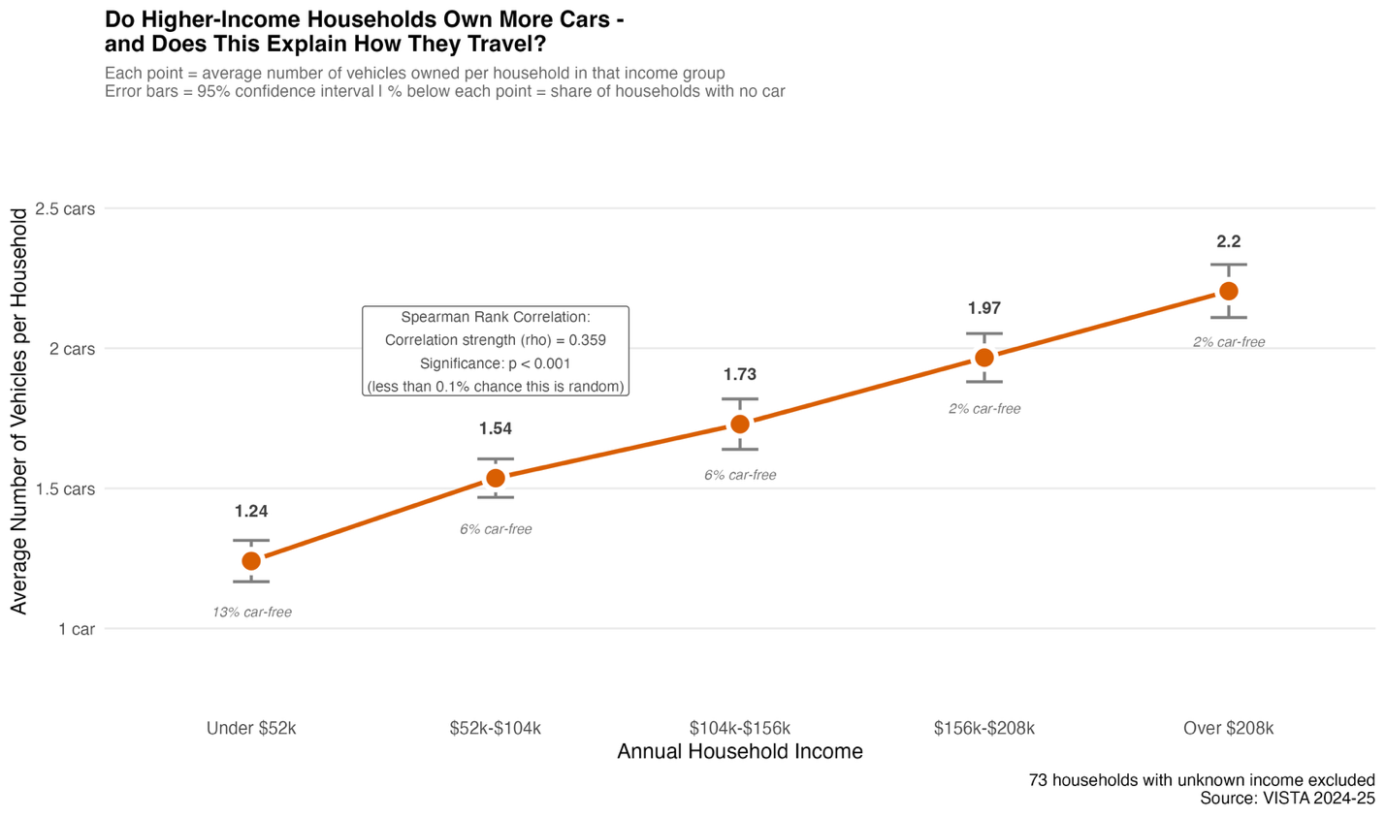
Figure 5. Connected dot plot showing mean vehicle ownership per household across annual household income bands. Error bars represent 95% confidence intervals. Source: VISTA 2024–25.
Figure 5 addresses the mechanism behind Q2's mode share patterns by examining whether lower-income households own fewer vehicles — the primary constraint on private vehicle access. A Spearman rank correlation was selected over Pearson's r because household income bands are ordinal rather than continuous, and vehicle counts are discrete and non-normally distributed. The Spearman correlation between household income and vehicle ownership was rho = 0.359 (p < 0.001), confirming a moderate but statistically significant positive relationship.
Mean vehicle ownership rises consistently from 1.24 cars per household in the under-$52k income band to 2.20 cars in the over-$208k band. Correspondingly, the share of car-free households falls from 13% at the lowest income band to 2% at the highest. This provides a direct economic explanation for the higher active transport and public transport reliance observed in lower-income areas in Figure 3: restricted car access forces reliance on alternative modes rather than genuine mode preference. This is an important equity consideration for transport and infrastructure planning.

Research Question 3: How is government infrastructure investment distributed across Victorian areas relative to where households are located?
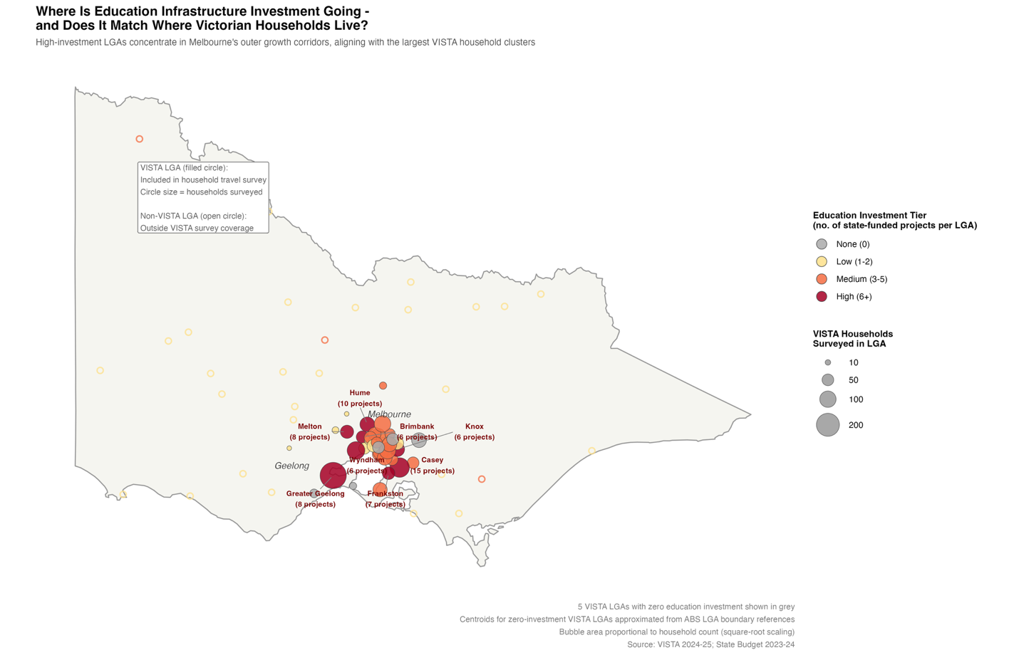
Figure 6. Bubble map of Victoria showing all LGAs with state-funded education projects. Filled circles represent LGAs covered by the VISTA survey, sized by number of households surveyed. Open circles represent Victorian LGAs outside VISTA coverage. Source: VISTA 2024–25; State Budget 2023–24.
Figure 6 uses a proportional symbol map — a bubble map — as the primary spatial idiom because it encodes two simultaneous dimensions: investment tier through colour and household presence through bubble size. This allows a reader to assess spatial alignment between investment and household density in a single view. Colour was mapped to investment tier using an ordered categorical colour scheme (grey for None, yellow for Low, orange for Medium, and dark red for High) to make the gradient from low to high investment immediately readable. Bubble size was mapped to VISTA household count as a proxy for household density per LGA, with bubble area scaled using a square-root transformation to prevent high-count LGAs from visually dominating the map disproportionately.
The spatial pattern is unambiguous: all eight High-investment LGAs are located in Melbourne's outer growth corridors and Geelong. Casey received the most projects (15), followed by Hume (10), Greater Geelong (8), Melton (8), Frankston (7), and Knox, Wyndham, and Brimbank (6 each). These are also among the LGAs with the largest VISTA household clusters, visible as the largest bubbles on the map. Regional Victoria, by contrast, is dominated by small open circles — Low-investment LGAs with no VISTA household survey coverage. This reflects both the geographic scope of the VISTA survey (restricted to Greater Melbourne and Geelong) and the concentration of state infrastructure spending in population growth areas.
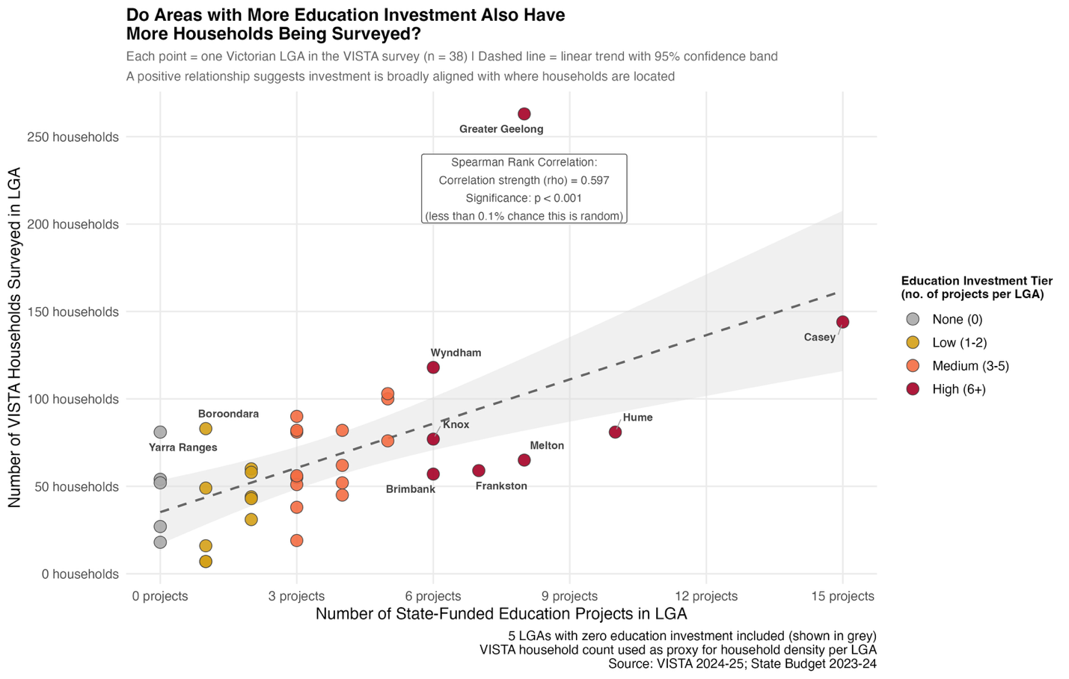
Figure 7. Scatter plot showing the relationship between the number of state-funded education projects and the number of VISTA households surveyed per LGA (n = 38). Dashed line shows linear trend with 95% confidence band. Source: VISTA 2024–25; State Budget 2023–24.
Figure 7 quantifies the spatial alignment observed in Figure 6 through a scatter plot with a linear trend line. A scatter plot was selected because it clearly displays the bivariate relationship between two continuous variables while preserving individual LGA identities through labelling and colour coding by investment tier. A Spearman rank correlation was applied because both variables are count-based and the relationship is not assumed to be linear. The correlation between project count and household count across all 38 VISTA LGAs (including five with zero projects) was rho = 0.597 (p < 0.001), indicating a moderate-to-strong positive relationship that is statistically significant.
Two notable outliers are visible in Figure 7. Greater Geelong sits well above the trend line, with 8 projects but 263 surveyed households — the largest household cluster in the dataset. This reflects Geelong's status as a major regional city with substantial population rather than an outer Melbourne suburb. Casey sits below the trend line with the most projects (15) but a household count of 144, suggesting investment concentration exceeds proportional household representation. Taken together, Figures 6 and 7 confirm that while there is a broadly positive spatial alignment between education investment and household presence in Victoria, the relationship is imperfect — some high-population LGAs are underserved relative to their size, and not all investment concentrations correspond to the highest household densities.

4. Conclusion
This project explored the intersection of educational infrastructure investment, neighbourhood socioeconomic status, and household travel behaviour across Victorian LGAs using three complementary datasets. Across seven visualisations and four statistical tests, three broad findings emerged.
For Q1, travel mode choices differ meaningfully across investment tiers, but the relationship is not straightforward. Higher-investment areas show greater private vehicle dependence for both work and education trips, reflecting the outer suburban geography of those LGAs rather than any direct effect of infrastructure investment. Trip durations for education — but not work — are significantly longer in Medium-investment LGAs compared to areas with no investment.
For Q2, wealthier neighbourhoods show meaningfully higher active transport use and lower private vehicle dependence, driven in part by geography and in part by household income constraints on vehicle ownership. Lower-income households own significantly fewer cars — a structural constraint that limits transport choices independently of neighbourhood characteristics.
For Q3, government education investment is broadly aligned with where households are located, with a Spearman correlation of 0.597 (p < 0.001) between project count and surveyed household count across VISTA LGAs. However, this alignment is imperfect: some large-population LGAs such as Greater Geelong receive fewer projects relative to their household base, while high investment does not always correspond to the highest household concentrations.
These findings collectively suggest that infrastructure investment in Victoria broadly follows population growth, but that equitable access to sustainable transport modes remains constrained by both geography and household economic capacity.

5. Reflection
This project reinforced several lessons about the practice of exploratory data analysis that I had not fully appreciated before undertaking it. The most significant was how much time and analytical judgement is required before a single visualisation is produced. Decisions made during wrangling — which LGA names to standardise, whether to treat survey refusals as missing data or as a valid category, how to handle overnight trips — directly shaped what the charts were able to show. Had these decisions been made carelessly, the analysis would have been technically correct but analytically misleading.
The second lesson concerned chart selection. My initial approach for Q2 was a heatmap, which I only reconsidered after realising that the colour scale could not differentiate meaningful variation across modes with very different magnitudes. Replacing it with a connected dot plot improved interpretability substantially. This reinforced the principle that chart type should serve the question being asked, not the analyst's familiarity with a particular idiom.
In hindsight, I would have spent more time at the outset explicitly mapping each research question to the specific variables, datasets, and statistical methods needed to answer it, rather than discovering these connections iteratively during analysis. This would have reduced the number of chart revisions and allowed more time for deeper exploration — for example, examining seasonal variation in travel behaviour or investigating whether the mode shift at higher SEIFA deciles holds when controlling for trip purpose. These remain open threads for future work.

Bibliography
Australian Bureau of Statistics. (2023). Socio-Economic Indexes for Areas (SEIFA), Australia, 2021. ABS. https://www.abs.gov.au/statistics/people/people-and-communities/socio-economic-indexes-areas-seifa-australia/2021
Department of Transport and Planning, Victoria. (2025). Victorian Integrated Survey of Travel and Activity (VISTA) 2024–25. Victorian Government Open Data. https://opendata.transport.vic.gov.au/dataset/174fbf40-bef0-434a-8af0-891c7f3d2323
Dunn, O. J. (1964). Multiple comparisons using rank sums. Technometrics, 6(3), 241–252. https://doi.org/10.1080/00401706.1964.10490181
Kruskal, W. H., & Wallis, W. A. (1952). Use of ranks in one-criterion variance analysis. Journal of the American Statistical Association, 47(260), 583–621. https://doi.org/10.1080/01621459.1952.10483441
Spearman, C. (1904). The proof and measurement of association between two things. The American Journal of Psychology, 15(1), 72–101. https://doi.org/10.2307/1412159
Victorian Department of Treasury and Finance. (2023). 2023–24 Victorian State Budget – Infrastructure Investment Map. Victorian Government. https://discover.data.vic.gov.au/dataset/ed30724b-6ae7-4713-aff3-4f00b3666684

Generative AI Declaration
This report was completed with the assistance of Claude (Anthropic, claude-sonnet-4-6), accessed via claude.ai. The AI tool was used throughout the data exploration and report writing process. Key prompts used included: providing the full project context, cleaned dataset descriptions, and research questions, then iteratively requesting R visualisation code for each chart (one chart at a time), verifying outputs against raw data using Python, requesting corrections when charts contained errors or unclear labelling, and requesting report content for each section based on verified chart outputs and documented wrangling decisions. All statistical results, chart values, and analytical interpretations were verified against the raw data before inclusion. The code and written content generated by the AI tool were reviewed, corrected where necessary, and adapted to reflect the specific findings of this analysis.

Appendix
The following figures were produced during the data checking process to visually identify irregularities in the raw dataset. They are placed here to preserve space in the main report.

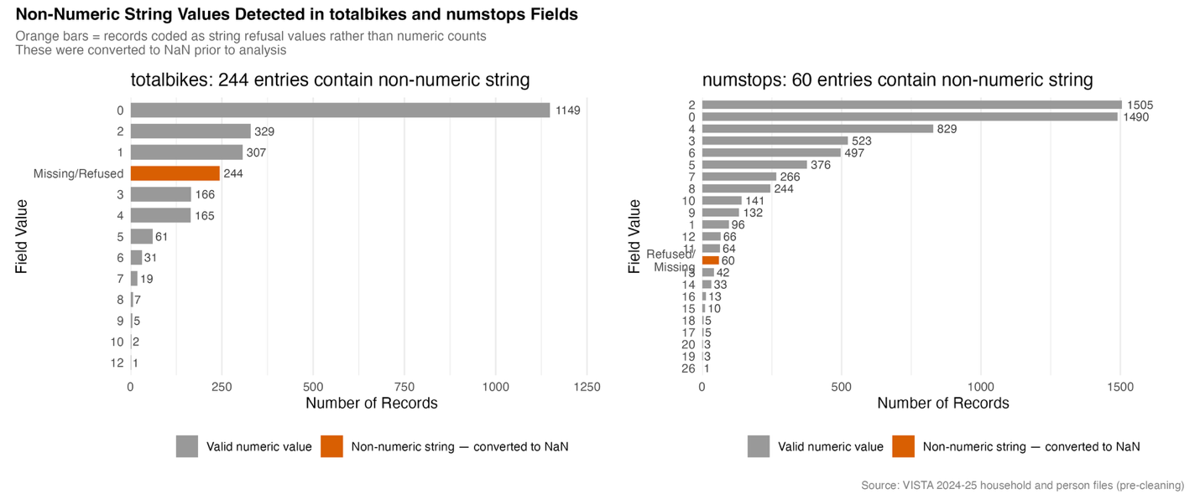
Figure A1. Value distributions of the totalbikes field (household file, left panel) and numstops field (person file, right panel) prior to cleaning. Orange bars indicate records coded as non-numeric string refusal values rather than numeric counts — 244 records in totalbikes and 60 records in numstops. Both fields were converted to NaN prior to analysis. Source: VISTA 2024–25.
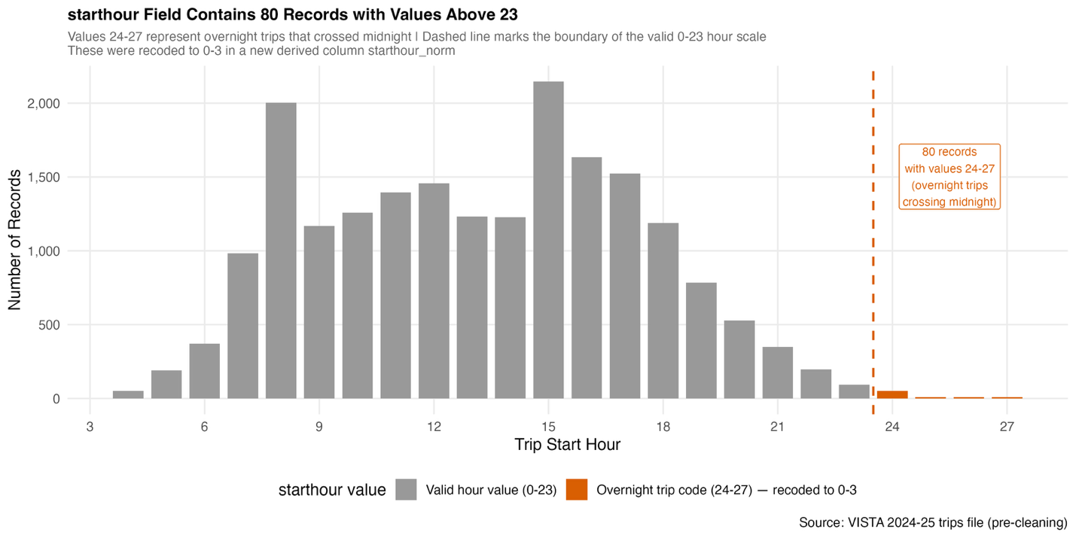
Figure A2. Distribution of trip start hour values in the raw trips file. The 80 records with values 24–27, shown in orange to the right of the dashed line, represent overnight trips that crossed midnight and were incorrectly recorded beyond the valid 0–23 hour scale. These were recoded to 0–3 in a new derived column. Source: VISTA 2024–25.
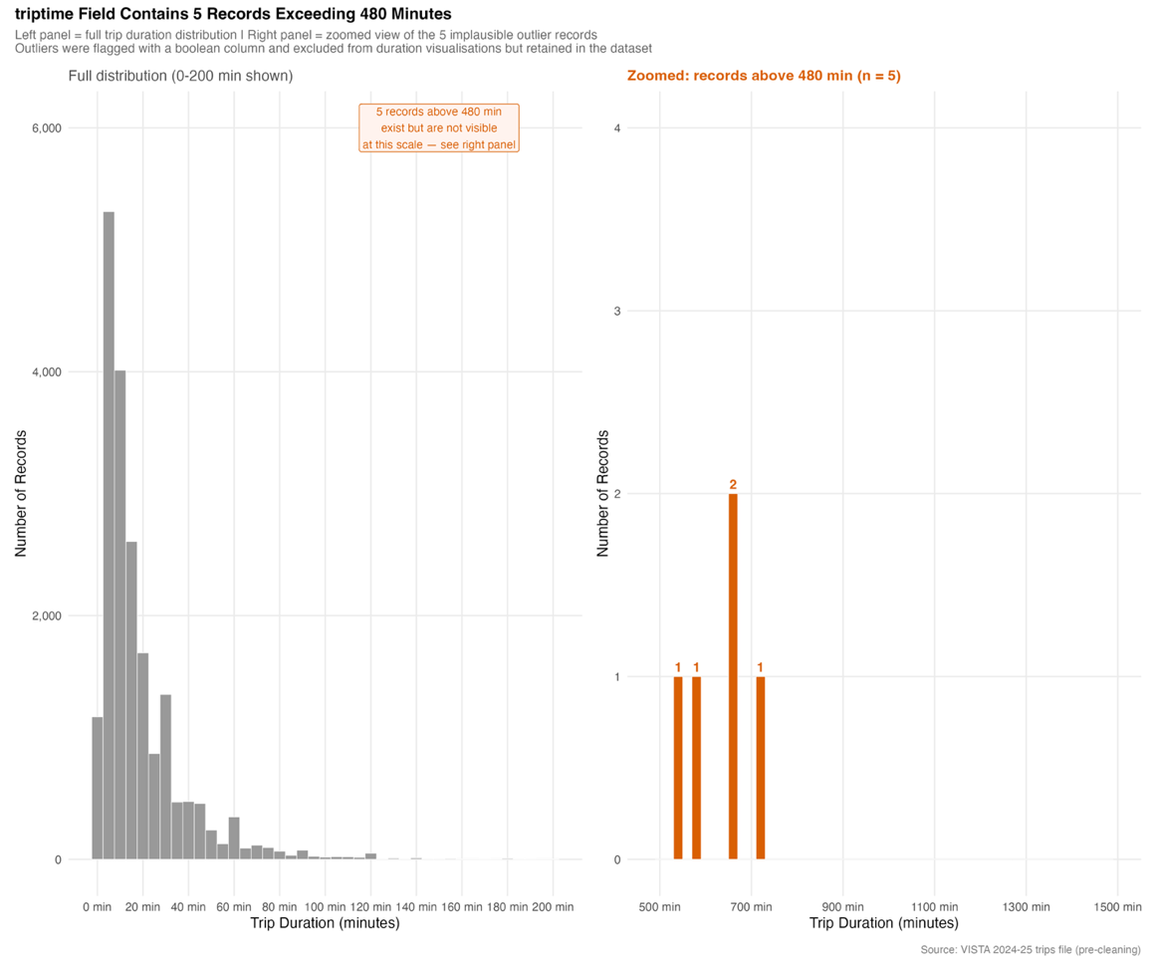
Figure A3. Distribution of trip duration values in the raw trips file shown across two panels. The left panel shows the full distribution; the right panel zooms into the region above 480 minutes, where 5 records are visible in orange. These outliers are implausible for a single-day urban trip and were flagged with a boolean column and excluded from duration visualisations but retained in the dataset. Source: VISTA 2024–25.

